Manila Water Company
technical specification – FORM
DD_M2C_119
Receipt Printing



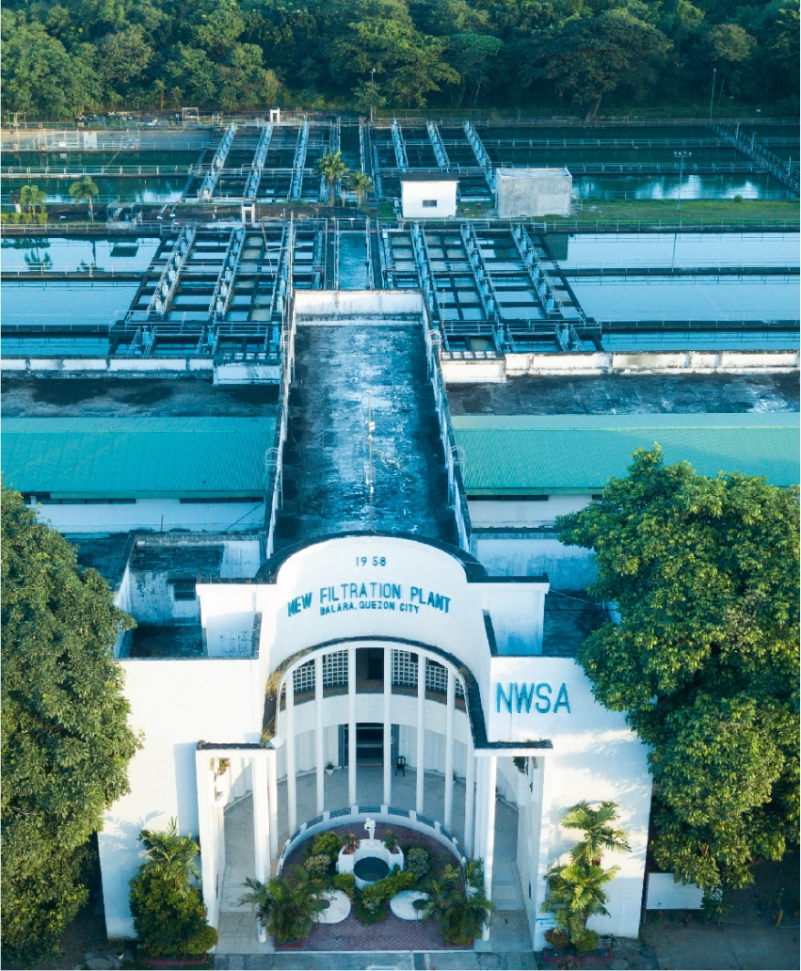
Contents
1 Document Organization 4
1.1 Document Log 4
1.2 Integration, Document Reference 4
2 Program Attributes 5
2.1 Authorization Requirements 5
2.1.1 Definition 5
2.1.2 Defined Fields 5
2.1.3 Procedure 5
2.2 Technical Flow Diagram 5
2.3 Form adjustment steps [New output management only] 5
2.4 Output Control Configuration 6
2.5 Form Processing Logic 6
3 Assumptions in Technical Design 6
4 Open Issues in Technical Design 6
5 Unit Test Results 6
6 Related Documentation 7

Document Organization
This section provides details about this document, previous version(s) of this document and the document(s) referred.

Document Log
The following table mentions the version changes and the processer(s):
Version | Status | Date | Version Created by (Name/E-Mail/Company) | Role | Comments
 | Ready for Review | April 12, 2025 | Kritika Kumawat | Author
 | Choose an item. | Click here to enter a date. |  | Choose an item.

Integration, Document Reference

S. No. | Referred Document Name | Referred Document Version | Referred Document URL (Optional)

Program Attributes
Form title
Form Name | ZAF_M2C_CA_CASH_RECEIPT_PDF
Package | ZS4_MWC_M2C_FICA
Print/Driver Program
Form Interface | ZIF_M2C_CA_CASH_RECEIPT_PDF
Fragment Details
Gateway Service
Smart Style/Script Style
Logo Name | Logo Based on Company Codes
Function Module Name

Authorization Requirements

Definition
This form can be printed in Real time at the cash desk while customer paid their bills.
If the customer paid their bills at Payment facility in that case customer visit the MWC branch/location and requested for Receipt. In that case the MWC agent will print the receipt.

Defined Fields
N/A

Procedure
Two structures are given as input in which one contains Document number and other related information (Header Data in Open Item Accounting Document) while another one has print data.
The form will be generated with the details on the given structure data.

Technical Flow Diagram

Form adjustment steps [New output management only]
N/A

Output Control Configuration
N/A

Form Processing Logic
- To fetch company code text: -
Pass Document number into DFKKKO- OPBEL and take BUKRS and Pass BUKRS into T001- BUKRS and Take BUTXT.
- Based on the Company Code get Fixed Logo.
- To fetch Business Place Address: - Firstly pick the ADRNR field value from table J_1BBRANCH-ADRNR field then pass the J_1BBRANCH-ADRNR field value in FM ADDR_GET_COMPLETE-ADDRNUMBER field and finally get the address details from export parameter ADDR1_COMPLETE under ADDR1_TAB.
- To get the official receipt number pass the payment document number into DFKKEXTDOC-EXKEY and take EXBEL value.
- Document Date and Posting Date (DFKKZP-BUDAT)
- To fetch business partner and business name (account number): -
Pass Document number (DFKKOP-OPBEL) generated from cash desk transaction to fetch Business Partner (DFKKOP-GPART).
Pass GPART into BUT000- PARTNER and take NAME_ORG1, NAME_ORG2, NAME_ORG3
- To fetch Business Partner Address: –
Following separated by space: -
House Number BP_ADDRESS-HOUSE_NUM1
Street BP_ADDRESS-STREET
Postal Code BP_ADDRESS-POST_CODE1
City BP_ADDRESS-CITY1
District BP_ADDRESS-CITY2
Region BP_ADDRESS-REGION
Country/Region Key BP_ADDRESS-COUNTRY
- To fetch TIN using BP Number: -
Pass BP Number into BUT0ID- PARTNER and TYPE= ZID007 and take IDNUMBER.
- Contract account DFKKOP-VKONT
- Payment Date (Date on which document posted)
- User ID corresponds to Name first name and Last name.
- For Heading check Water Revenue: -
Payment is against only Water Revenue than Heading is Water Revenue. If HVORG (0100, 0200 and 0300) then it is Water revenue.
If Payment is against Misc Charges, then heading is Misc Revenue. If HVORG (6000) then it is Misc Charges.
If Payment is Mix of Water and Misc Charges, then heading is Various Revenue.
- To Fetch Vatable Sales: -
Pass Document number into DFKKOP-AUGBL and KOFIZ (AD ID) = C1, I1, R1 and HVORG(0100,0200 and 0300) and TVORG( 0010,0011,0012,0013,0014,0015,0017,0020,0021,0022, 0023, 0024, 0025, 0027, 0028, 0029, 0030, 0031, 0032, 0033,0200 and 0201, then take DFKKOP-BETRW where MWSKZ= O3 (deduct DFKKOP- SCTAX amount from DFKKOP-BETRW and show net amount).
If it is Misc revenue than HVORG (6000) and TVORG 0020,0035,0037,0041 then take DFKKOP-BETRW (deduct DFKKOP- SCTAX amount from DFKKOP-BETRW and show net amount).
- To fetch vat exempted sales: -
Pass Document number into DFKKOP-AUGBL and KOFIZ (AD ID) = C1, I1, R1 and HVORG (0100,0200 and 0300) and TVORG (0010, 0011, 0012, 0013, 0014, 0015, 0017, 0020, 0021, 0022, 0023, 0024, 0025, 0027, 0028, 0029, 0030, 0031, 0032, 0033, 0200 and 0201, then take DFKKOP-BETRW
- To fetch Vat zero rated: -
Pass Document number into DFKKOP-AUGBL and KOFIZ (AD ID) = C2, I2, R2 and HVORG (0100,0200 and 0300) and TVORG (0010, 0011, 0012, 0013, 0014, 0015, 0017, 0020, 0021, 0022, 0023, 0024, 0025, 0027, 0028, 0029, 0030, 0031, 0032, 0033, 0200 and 0201, then take DFKKOP-BETRW
- To fetch vat: -
Take logic from -S. No17 and take amount from DFKKOP- SCTAX where DFKKOP- MWSKZ= O3.
- To fetch govt. taxes: -
Take logic from -S. No17,18 and 19 and take amount from DFKKOP- SCTAX where DFKKOP- MWSKZ= H1-H5, M-M5, R1, F1-F4, S1-S8
- Calculating net of vat: - Sum of vat sales + exempted vat sales + vat zero.
- Total Sales (VAT Inclusive): - Sum of vat sales + exempted vat sales + vat zero + vat.
- To fetch SC/PWD With Held: -
Pass Document number into DFKKOP-AUGBL and take HVORG and TVORG
Pass Document number into DFKKOP-OPBEL and take HVORG and TVORG
- To fetch the total amount paid: -
Take amount from DFKKZP
If Customer paid Excess amount, in this total paid amount will show in this filed.
If Customer Payment went Clarification, then will consider only payment document (document which posted in customer account) will be considered.
- Fetch Payment Mode: -
If Payment is by cash, then Mark as cash Payment
If payment is by check, then mark as Check payment.
If payment is other than Cash and Check, then Mark X in others
Payment by Cash: Pass document number into DFKKKO-OPBEL and check HERKF. If HERKF EQ 19 or 21 then these payments through Cash Desk then pass Payment document number into DFKKZP- OPBEL and take KEYZ1 and Pass KEYZ1 into DFKKCJT- PRKEY and check PAYTP, If PAYTP=CS then it is cash payment if PAYTP=CH than it is check payment.
Payment through Payment facility: In this case check DFKKKO-OPBEL and check HERKF is 05 then this is cash payment. If HERKF is 25 then it is checking payment. All other cases mark then as others.
- To fetch Bank/Card number: -
Get CHCKN from DFKKZP passing document number in OPBEL
- To fetch Check/Card Number: -
Get INFOF from DFKKZP passing document number in OPBEL
- To fetch amount in words: -
FM to convert Amount into words.

Assumptions in Technical Design
N/A

Open Issues in Technical Design
N/A

Unit Test Results

Scenario # | Input Selection Criteria | Expected Result | Actual Test Pass/Fail
1. | Customer Paid at Cash desk and requested receipt | MWC agent post payments through FPCJ and Print the Receipt | Pass
2. | Customer later approach MWC agent and request receipt. | MWC agent print receipt through FPCJ or FPCOPARA. Receipt printed on the local printer. | Pass
3. | Customer Paid at payment facility and approach nearest service area and requested for Receipt Print. | MWC agent prints receipt through FPCOPARA. Receipt printed on the local printer. | Pass

Related Documentation

Template Version

Version | Status | Date | Version Created by (Name/E-Mail/Company) | Role | Comments
1.0 | Final | February 11, 2019 | Abhishek Nayak | Author
 | Choose an item. | Click here to enter a date. |  | Choose an item.

